Thread 7d84f0c8
Source: https://faq.remarkbox.com/7d84f0c8-8d9a-11e8-906e-040140774501
Snapshot: 2026-05-02T12:54:38Z
Generator: Remarkbox 763cacb
This is a subthread snapshot. The living document lives at the source URI above — it may have been edited, extended, or replied-to since.
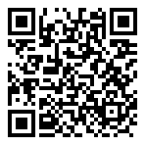
Scan for living source
سلام Do you support Farsi and Arabic?

Source: https://faq.remarkbox.com/7d84f0c8-8d9a-11e8-906e-040140774501
Snapshot: 2026-05-02T12:54:38Z
Generator: Remarkbox 763cacb

