How do I add myself as moderator to my namespace?
Source: https://faq.remarkbox.com/3f100705-978f-11f1-bcb8-040140774501/how-do-i-add-myself-as-moderator-to-my-namespace
Snapshot: 2026-08-15T08:20:07Z
Generator: Remarkbox b4670c4
This is a thread snapshot. The living document lives at the source URI above — it may have been edited, extended, or replied-to since.
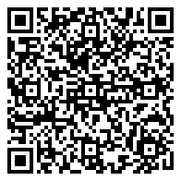
Scan for living source
My namespace settings don't have anyone listed as a moderator, and I don't see a way to add anyone. I also can't get to the moderation panels, even though I'm the namespace owner.

Source: https://faq.remarkbox.com/3f100705-978f-11f1-bcb8-040140774501/how-do-i-add-myself-as-moderator-to-my-namespace
Snapshot: 2026-08-15T08:20:07Z
Generator: Remarkbox b4670c4

